**Assignment**

**MODULE: 2 SE – HTML and CSS**

**Q1.** **Define the terms: Website, Webpage, Web browser, Web server, HTML, CSS**

**Ans.** Website: -It is a mode of delivering an information to the end user which are connected to it. It is also known as collection of a linked webpages that share a unique domain name.

Webpage: - It is page where all the information is placed and displayed as a document on a browser.

Web browser: - It is a software which is used to access information from the World Wide Web.

Web server: - It is a place where all the content is stored. Web server is “always on” so that any client’s computer can get connected and executes the requests.

HTML: - HTML means hyper text markup language. Html is used to create structure of web page.

CSS: - CSS stands for Cascading Style Sheets. It defines how HTML elements are to be displayed and saves lot of work and time this means that the same content can be used with many styles.

**Q2.** **Create a webpage to show “This is my first HTML page”**

**Ans.**

<!DOCTYPE html>

<html lang="en">

<head>

    <meta charset="UTF-8">

    <meta http-equiv="X-UA-Compatible" content="IE=edge">

    <meta name="viewport" content="width=device-width, initial-scale=1.0">

    <title>Document</title>

</head>

<body>

    <!-- This is where all information or content is written  -->

    <h1>This is my first HTML page</h1>

</body>

</html>



**Q3. Display top 10 IT companies list in html webpage.**

**Ans.**

<!DOCTYPE html>

<html lang="en">

<head>

    <meta charset="UTF-8">

    <meta http-equiv="X-UA-Compatible" content="IE=edge">

    <meta name="viewport" content="width=device-width, initial-scale=1.0">

    <title>Document</title>

</head>

<body>

    <h1>Top 10 IT companies list.</h1>

    <!-- This is Order List -->

    <ol>

        <li> eSparkBiz  </li>

        <li>Tata Consultancy Services </li>

        <li>Infosys </li>

        <li>HCL Technologies </li>

        <li>Tech Mahindra</li>

        <li>Mphasis</li>

        <li> Wipro</li>

        <li>Hexaware Technologies</li>

        <li>Mindtree </li>

        <li>Seqato </li>

    </ol>

    <!-- This is Unorder List  -->

    <ul>

        <li> eSparkBiz  </li>

        <li>Tata Consultancy Services </li>

        <li>Infosys </li>

        <li>HCL Technologies </li>

        <li>Tech Mahindra</li>

        <li>Mphasis</li>

        <li> Wipro</li>

        <li>Hexaware Technologies</li>

        <li>Mindtree </li>

        <li>Seqato </li>

    </ul>

</body>

</html>



**Q4. Create a dropdown list**

**Ans.**

<!DOCTYPE html>

<html lang="en">

<head>

    <meta charset="UTF-8">

    <meta http-equiv="X-UA-Compatible" content="IE=edge">

    <meta name="viewport" content="width=device-width, initial-scale=1.0">

    <title>Document</title>

</head>

<body>

    <table>

        <tr>

            <td>

                <!-- lable is given  -->

                <label for="">Select your Country:</label>

            </td>

            <td>

                <!-- Select and option tags is used to make dropdown list    -->

                <select name="" id="">

                    <option value="" selected="selected" disabled="disabled">Select your Country</option>

                    <option value="">India</option>

                    <option value="">Canada</option>

                </select></td>

        </tr>

    </table>

</body>

</html>



**Q5. Create a Table Of college Management system using row span & col span.**

**Ans.**

<!DOCTYPE html>

<html lang="en">

<head>

    <meta charset="UTF-8">

    <meta http-equiv="X-UA-Compatible" content="IE=edge">

    <meta name="viewport" content="width=device-width, initial-scale=1.0">

    <title>Document</title>

</head>

<body>

    <h1 align="center"><strong>Time Table</strong></h1>

    <!-- biorder 5 is used to make border visible and cellspacing is done 0 so no space is there

         inside the border  -->

    <table border="5" cellspacing="0" align="center">

        <tr>

            <th align="center" Width="120">Day/Period</th>

            <th align="center" Width="120">I<br>9:30-10:20</th>

            <th align="center" Width="120">II<br>10:20-11:10</th>

            <th align="center" Width="120">III<br>11:10-12:00</th>

            <th align="center" Width="120">12:00-12:40</th>

            <th align="center" Width="120">IV<br>12:40-1:30</th>

            <th align="center" Width="120">V <br>1:30-2:20</th>

            <th align="center" Width="120">VI <br>2:20-3:10</th>

            <th align="center" Width="120">VII <br>3:10-4:00</th>

        </tr>

        <tr>

            <th align="center" Height="40">Monday</th>

            <td align="center" Height="40">Eng</td>

            <td align="center" Height="40">Mat</td>

            <td align="center" Height="40">che</td>

            <!-- Rowspan=6 is used to cover 6 rows as one row   -->

            <th align="center" Height="40" rowspan="6">L <br>U <br>N <br>C <br>H</th>

            <!-- colspan=6 is used to cover 3 column as one column   -->

            <td align="center" Height="40" colspan="3">LAB</td>

            <td align="center" Height="40">Phy</td>

        </tr>

        <tr>

            <th align="center" Height="40">Tuesday</th>

            <!-- colspan=6 is used to cover 3 column as one column   -->

            <td align="center" Height="40" colspan="3">LAB</td>

            <td align="center" Height="40">Eng</td>

            <td align="center" Height="40">Che</td>

            <td align="center" Height="40">Mat</td>

            <td align="center" Height="40">SPORTS</td>

        </tr>

        <tr>

            <th align="center" Height="40">Wednesday</th>

            <td align="center" Height="40">Mat</td>

            <td align="center" Height="40">Phy</td>

            <td align="center" Height="40">Eng</td>

            <td align="center" Height="40">Che</td>

            <!-- colspan=6 is used to cover 3 column as one column   -->

            <td align="center" Height="40" colspan="3">LIBRARY</td>

        </tr>

        <tr>

            <th align="center" Height="40">Thursday</th>

            <td align="center" Height="40">Phy</td>

            <td align="center" Height="40">Eng</td>

            <td align="center" Height="40">Che</td>

            <!-- colspan=6 is used to cover 3 column as one column   -->

            <td align="center" Height="40" colspan="3">LAB</td>

            <td align="center" Height="40">Mat</td>

        </tr>

        <tr>

            <th align="center" Height="40">Friday</th>

            <!-- colspan=6 is used to cover 3 column as one column   -->

            <td align="center" Height="40" colspan="3">LAB</td>

            <td align="center" Height="40">Mat</td>

            <td align="center" Height="40">Che</td>

            <td align="center" Height="40">Eng</td>

            <td align="center" Height="40">Phy</td>

        </tr>

        <tr>

            <th align="center" Height="40">Saturday</th>

            <td align="center" Height="40">Eng</td>

            <td align="center" Height="40">Che</td>

            <td align="center" Height="40">Mat</td>

            <!-- colspan=6 is used to cover 3 column as one column   -->

            <td align="center" Height="40" colspan="3">SEMINAR</td>

            <td align="center" Height="40">SPORTS</td>

        </tr>

    </table>

</body>

</html>

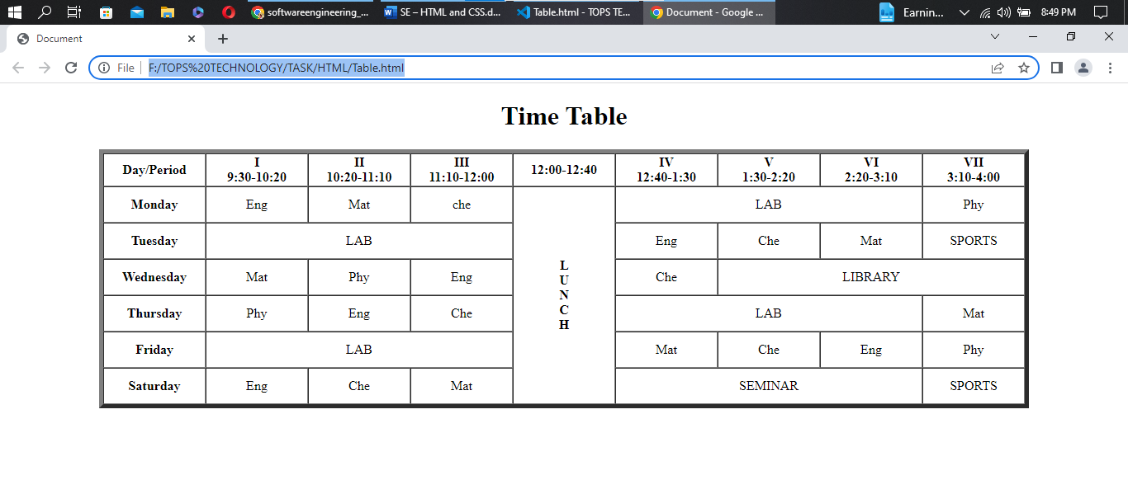

**Q6.** **Create below table using HTML table tags.**

**Ans.**

<!DOCTYPE html>

<html lang="en">

<head>

    <meta charset="UTF-8">

    <meta http-equiv="X-UA-Compatible" content="IE=edge">

    <meta name="viewport" content="width=device-width, initial-scale=1.0">

    <title>Document</title>

</head>

<body bgcolor="green">

    <h1 align="center">European Roulette</h1>

        <!-- biorder=1 is used to make border visible and cellspacing=0 is done so no space is there

         inside the border, it is aligen to center as well as bordercolor is also applied  -->

    <table border="1" cellspacing="0" align="center" bordercolor="#FFF192">

        <!-- This is First row  -->

        <!-- Rowspan=5 is used to cover 5 row as a one  -->

        <tr>

            <td rowspan="5" align="center" Width="60" Height="60">

                <font color="#FFF192"> 0</font>

            </td>

            <td align="center" Width="60" Height="60" bgcolor="#bf0000">

                <font color="#FFF192"> 3</font>

            </td>

            <td align="center" Width="60" Height="60" bgcolor="black">

                <font color="#FFF192"> 6</font>

            </td>

            <td align="center" Width="60" Height="60" bgcolor="#bf0000">

                <font color="#FFF192"> 9</font>

            </td>

            <td align="center" Width="60" Height="60" bgcolor="#bf0000">

                <font color="#FFF192"> 12</font>

            </td>

            <td align="center" Width="60" Height="60" bgcolor="black">

                <font color="#FFF192"> 15</font>

            </td>

            <td align="center" Width="60" Height="60" bgcolor="#bf0000">

                <font color="#FFF192"> 18</font>

            </td>

            <td align="center" Width="60" Height="60" bgcolor="#bf0000">

                <font color="#FFF192"> 21</font>

            </td>

            <td align="center" Width="60" Height="60" bgcolor="black">

                <font color="#FFF192"> 24</font>

            </td>

            <td align="center" Width="60" Height="60" bgcolor="#bf0000">

                <font color="#FFF192"> 27</font>

            </td>

            <td align="center" Width="60" Height="60" bgcolor="#bf0000">

                <font color="#FFF192"> 30</font>

            </td>

            <td align="center" Width="60" Height="60" bgcolor="black">

                <font color="#FFF192"> 33</font>

            </td>

            <td align="center" Width="60" Height="60" bgcolor="#bf0000">

                <font color="#FFF192"> 36</font>

            </td>

            <td Width="100" Height="50">

                <font color="#FFF192"> 2to1

            </td>

        </tr>

        <!-- This is Second row  -->

        <tr>

            <td align="center" Width="60" Height="60" bgcolor="black">

                <font color="#FFF192"> 2</font>

            </td>

            <td align="center" Width="60" Height="60" bgcolor="#bf0000">

                <font color="#FFF192"> 5</font>

            </td>

            <td align="center" Width="60" Height="60" bgcolor="black">

                <font color="#FFF192"> 8</font>

            </td>

            <td align="center" Width="60" Height="60" bgcolor="black">

                <font color="#FFF192"> 11</font>

            </td>

            <td align="center" Width="60" Height="60" bgcolor="#bf0000">

                <font color="#FFF192"> 14</font>

            </td>

            <td align="center" Width="60" Height="60" bgcolor="black">

                <font color="#FFF192"> 17</font>

            </td>

            <td align="center" Width="60" Height="60" bgcolor="black">

                <font color="#FFF192"> 20</font>

            </td>

            <td align="center" Width="60" Height="60" bgcolor="#bf0000">

                <font color="#FFF192"> 23</font>

            </td>

            <td align="center" Width="60" Height="60" bgcolor="black">

                <font color="#FFF192"> 26</font>

            </td>

            <td align="center" Width="60" Height="60" bgcolor="black">

                <font color="#FFF192"> 29</font>

            </td>

            <td align="center" Width="60" Height="60" bgcolor="#bf0000">

                <font color="#FFF192"> 32</font>

            </td>

            <td align="center" Width="60" Height="60" bgcolor="black">

                <font color="#FFF192"> 35</font>

            </td>

            <td Width="100" Height="50">

                <font color="#FFF192"> 2to1

            </td>

        </tr>

        <!-- This is Third row  -->

        <tr>

            <td align="center" Width="60" Height="60" bgcolor="#bf0000">

                <font color="#FFF192"> 1</font>

            </td>

            <td align="center" Width="60" Height="60" bgcolor="black">

                <font color="#FFF192"> 4</font>

            </td>

            <td align="center" Width="60" Height="60" bgcolor="#bf0000">

                <font color="#FFF192"> 7</font>

            </td>

            <td align="center" Width="60" Height="60" bgcolor="black">

                <font color="#FFF192"> 10</font>

            </td>

            <td align="center" Width="60" Height="60" bgcolor="black">

                <font color="#FFF192"> 13</font>

            </td>

            <td align="center" Width="60" Height="60" bgcolor="#bf0000">

                <font color="#FFF192"> 16</font>

            </td>

            <td align="center" Width="60" Height="60" bgcolor="#bf0000">

                <font color="#FFF192"> 19</font>

            </td>

            <td align="center" Width="60" Height="60" bgcolor="black">

                <font color="#FFF192"> 22</font>

            </td>

            <td align="center" Width="60" Height="60" bgcolor="#bf0000">

                <font color="#FFF192"> 25</font>

            </td>

            <td align="center" Width="60" Height="60" bgcolor="black">

                <font color="#FFF192"> 28</font>

            </td>

            <td align="center" Width="60" Height="60" bgcolor="black">

                <font color="#FFF192"> 31</font>

            </td>

            <td align="center" Width="60" Height="60" bgcolor="#bf0000">

                <font color="#FFF192"> 34</font>

            </td>

            <td Width="100" Height="50">

                <font color="#FFF192"> 2to1

            </td>

        </tr>

        <!-- This is Forth row  -->

        <tr>

            <td colspan="4" align="center" Width="60" Height="60">

                <font color="#FFF192"> 1st12

            </td>

            <td colspan="4" align="center" Width="60" Height="60">

                <font color="#FFF192"> 2nd12

            </td>

            <td colspan="4" align="center" Width="60" Height="60">

                <font color="#FFF192"> 3rd12

            </td>

            <td rowspan="2" align="center" Width="10red0" Height="60"></td>

        </tr>

        <!-- This is Fifth row   -->

        <!-- Colspan=2 is used to cover 2 column in one  -->

        <tr>

            <td colspan="2 " align="center" Width="60" Height="60">

                <font color="#FFF192"> 1to18</font>

            </td>

            <td colspan="2 " align="center" Width="60" Height="60">

                <font color="#FFF192"> EVEN</font>

            </td>

            <td colspan="2 " bgcolor="#bf0000" align="center" Width="60" Height="60"></td>

            <td colspan="2 " bgcolor="black" align="center" Width="60" Height="60"></td>

            <td colspan="2 " align="center" Width="60" Height="60">

                <font color="#FFF192"> ODD</font>

            </td>

            <td colspan="2 " align="center" Width="60" Height="60">

                <font color="#FFF192"> 19to36</font>

            </td>

        </tr>

    </table>

</body>

</html>

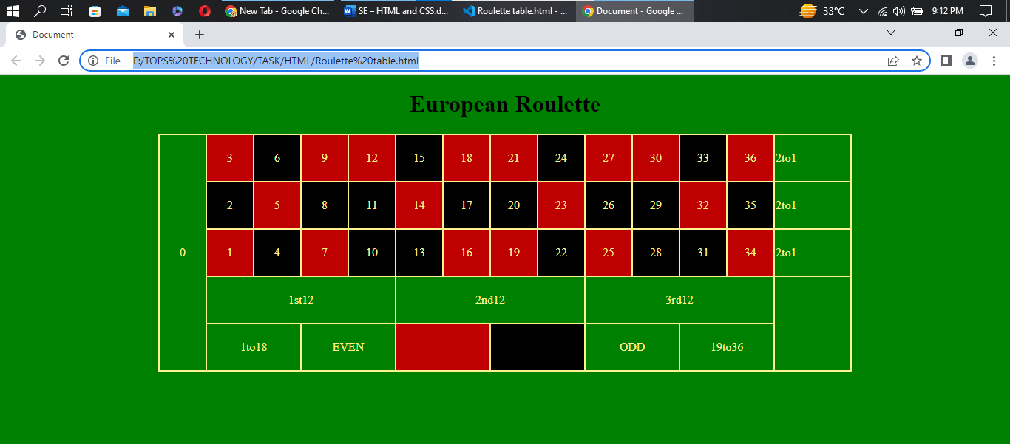

**Q7. Create Registration form using HTML, CSS.**

**Ans.**

<!DOCTYPE html>

<html lang="en">

<head>

    <meta charset="UTF-8">

    <meta http-equiv="X-UA-Compatible" content="IE=edge">

    <meta name="viewport" content="width=device-width, initial-scale=1.0">

    <title>Document</title>

</head>

<body>

    <!-- Inline CSS is used on every line to make every words color white  -->

    <h1 style="color: #9B23D0;" align="center"><U>STUDENT REGISTRATION FORM</U></h1>

    <fieldset>

        <table bgcolor="#9B23D0" align="center">

            <form action="">

                <tr>

                    <!-- Inline CSS  -->

                    <td width="150" height="40" style="color: white;"><label for="">FIRST NAME</label></td>

                    <td style="color: white;"><input type="text" name="" id="" maxlength="30">

                        <label for="">(max 30 characters a-z and A-Z)</label>

                    </td>

                </tr>

                <tr>

                    <!-- Inline CSS  -->

                    <td width="150" height="40" style="color: white;"><label for="">LAST NAME</label></td>

                    <td style="color: white;"><input type="text" name="" id="" maxlength="30">

                        <label for="">(max 30 characters a-z and A-Z)</label>

                    </td>

                </tr>

                <tr>

                    <!-- Inline CSS  -->

                    <td width="150" height="40" style="color: white;"><label for="DOB">DATE OF BIRTH</label></td>

                    <td style="color: white;"><select name="" id="DOB">

                            <option value="" selected="selected" disabled="disabled">Day:</option>

                            <option value="">1</option>

                            <option value="">2</option>

                            <option value="">3</option>

                            <option value="">4</option>

                            <option value="">5</option>

                            <option value="">6</option>

                            <option value="">7</option>

                            <option value="">8</option>

                            <option value="">9</option>

                            <option value="">10</option>

                            <option value="">11</option>

                            <option value="">12</option>

                            <option value="">13</option>

                            <option value="">14</option>

                            <option value="">15</option>

                            <option value="">16</option>

                            <option value="">17</option>

                            <option value="">18</option>

                            <option value="">19</option>

                            <option value="">20</option>

                            <option value="">21</option>

                            <option value="">22</option>

                            <option value="">23</option>

                            <option value="">24</option>

                            <option value="">25</option>

                            <option value="">26</option>

                            <option value="">27</option>

                            <option value="">28</option>

                            <option value="">29</option>

                            <option value="">30</option>

                            <option value="">31</option>

                        </select>

                        <select name="" id="DOB">

                            <option value="" selected="selected" disabled="disabled">Month:</option>

                            <option value="">Jan</option>

                            <option value="">Feb</option>

                            <option value="">Mar</option>

                            <option value="">Apr</option>

                            <option value="">May</option>

                            <option value="">Jun</option>

                            <option value="">Jul</option>

                            <option value="">Aug</option>

                            <option value="">Sept</option>

                            <option value="">Oct</option>

                            <option value="">Nov</option>

                            <option value="">Dec</option>

                        </select>

                        <select name="" id="DOB">

                            <option value="" selected="selected" disabled="disabled">Year:</option>

                            <option value="">1999</option>

                            <option value="">2000</option>

                            <option value="">2001</option>

                            <option value="">2002</option>

                            <option value="">2003</option>

                            <option value="">2004</option>

                            <option value="">2005</option>

                            <option value="">2006</option>

                            <option value="">2007</option>

                            <option value="">2008</option>

                        </select>

                    </td>

                </tr>

                <tr>

                    <!-- Inline CSS  -->

                    <td width="150" height="40" style="color: white;"><label for="">EMAIL ID</label></td>

                    <td style="color: white;"><input type="email" name="" id=""></td>

                </tr>

                <tr>

                    <!-- Inline CSS  -->

                    <td width="150" height="40" style="color: white;"><label for="">MOBLIE NUMBER</label></td>

                    <td style="color: white;"><input type="number" name="" id="">

                        <label for="">(10 digit number)</label>

                    </td>

                </tr>

                <tr>

                    <!-- Inline CSS  -->

                    <td width="150" height="40" style="color: white;"><label for="">GENDER</label></td>

                    <td style="color: white;">

                        <label for="male">Male</label>

                        <input type="radio" name="gender" id="male">

                        <label for="femal">Female</label>

                        <input type="radio" name="gender" id="female">

                    </td>

                </tr>

                <tr>

                    <!-- Inline CSS  -->

                    <td width="150" height="40" style="color: white;"><label for="address">ADDRESS</label></td>

                    <td style="color: white;"><textarea name="" id="address" cols="40" rows="4"></textarea></td>

                </tr>

                <tr>

                    <!-- Inline CSS  -->

                    <td width="150" height="40" style="color: white;"><label for="">CITY</label></td>

                    <td style="color: white;"><input type="text" name="" id="" maxlength="30">

                        <label for="">(max 30 characters a-z and A-Z)</label>

                    </td>

                </tr>

                <tr>

                    <!-- Inline CSS  -->

                    <td width="150" height="40" style="color: white;"><label for="">PIN CODE</label></td>

                    <td style="color: white;"><input type="number" name="" id="" minlength="6" maxlength="6">

                        <label for="">(6 digit number)</label>

                    </td>

                </tr>

                <tr>

                    <!-- Inline CSS  -->

                    <td width="150" height="40" style="color: white;"><label for="">STATE</label></td>

                    <td style="color: white;"><input type="text" name="" id="">

                        <label for="">(max 30 characters a-z and A-Z)</label>

                    </td>

                </tr>

                <tr>

                    <!-- Inline CSS  -->

                    <td width="150" height="40" style="color: white;"><label for="">COUNTRY</label></td>

                    <td style="color: white;"><input type="text" name="" id="" value="India"></td>

                </tr>

                <tr>

                    <!-- Inline CSS  -->

                    <td width="150" height="40" style="color: white;"><label for="">HOBBIES</label></td>

                    <td height="60" style="color: white;">

                        <label for="Drawing">Drawing</label>

                        <input type="checkbox" name="hobbies" id="Drawing">

                        <label for="Singing">Singing</label>

                        <input type="checkbox" name="hobbies" id="Singing">

                        <label for="Dancing">Dancing</label>

                        <input type="checkbox" name="hobbies" id="Dancing">

                        <label for="Skecting">Skecting</label>

                        <input type="checkbox" name="hobbies" id="Skecting"><br>

                        <label for="">Others</label>

                        <input type="checkbox" name="" id="">

                        <input type="text" name="" id="">

                    </td>

                </tr>

                <tr>

                    <!-- Inline CSS  -->

                    <td width="150" height="40" style="color: white;">QUALIFICATION</td>

                    <td>

                        <table>

                            <tr>

                                <!-- Inline CSS  -->

                                <th style="color: white;">SI.NO.</th>

                                <th style="color: white;">Examination</th>

                                <th style="color: white;">Board</th>

                                <th style="color: white;">Percentage</th>

                                <th style="color: white;">Year of Passing</th>

                            </tr>

                            <tr>

                                <!-- Inline CSS  -->

                                <td style="color: white;">1</td>

                                <td style="color: white;">Class X</td>

                                <td><input type="text" name="" id=""></td>

                                <td><input type="text" name="" id=""></td>

                                <td><input type="text" name="" id=""></td>

                            </tr>

                            <tr>

                                <!-- Inline CSS  -->

                                <td style="color: white;">2</td>

                                <td style="color: white;">Class XII</td>

                                <td><input type="text" name="" id=""></td>

                                <td><input type="text" name="" id=""></td>

                                <td><input type="text" name="" id=""></td>

                            </tr>

                            <tr>

                                <!-- Inline CSS  -->

                                <td style="color: white;">3</td>

                                <td style="color: white;">Graduation</td>

                                <td><input type="text" name="" id=""></td>

                                <td><input type="text" name="" id=""></td>

                                <td><input type="text" name="" id=""></td>

                            </tr>

                            <tr>

                                <!-- Inline CSS  -->

                                <td style="color: white;">4</td>

                                <td style="color: white;">Masters</td>

                                <td><input type="text" name="" id=""></td>

                                <td><input type="text" name="" id=""></td>

                                <td><input type="text" name="" id=""></td>

                            </tr>

                            <tr>

                                <!-- Inline CSS  -->

                                <td></td>

                                <td></td>

                                <td align="center" style="color: white;">(10 char max)</td>

                                <td align="center" style="color: white;">(upto 2 decimal)</td>

                            </tr>

                        </table>

                    </td>

                </tr>

                <tr>

                    <!-- Inline CSS  -->

                    <td width="150" height="40" style="color: white;">COURSES <br> APPLIED FOR</td>

                    <td style="color: white;">

                        <label for="BCA">BCA</label>

                        <input type="radio" name="COURSES" id="BCA">

                        <label for="B.Com">B.Com</label>

                        <input type="radio" name="COURSES" id="B.Com">

                        <label for="B.Sc">B.Sc</label>

                        <input type="radio" name="COURSES" id="B.Sc">

                        <label for="B.A">B.A</label>

                        <input type="radio" name="COURSES" id="B.A">

                    </td>

                </tr>

                <tr>

                    <td colspan="2" align="center">

                        <input type="submit" name="" id="">

                        <input type="reset" name="" id="">

                    </td>

                </tr>

            </form>

        </table>

    </fieldset>

</body>

</html>

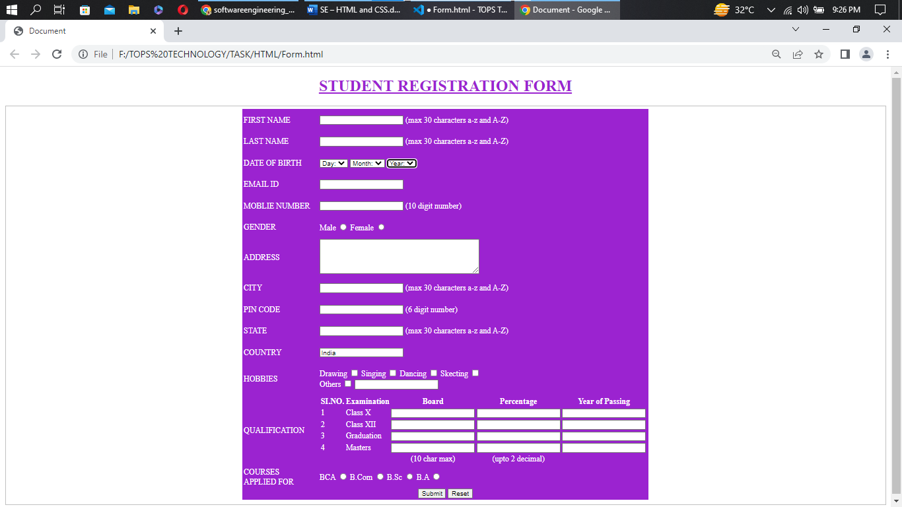

**Q8. In how many ways can a CSS be integrated as a web page?**

**Ans.** CSS can be integrated by three ways which is as follows

1. Inline CSS.

2. Internal CSS.

3. External CSS.

**Inline CSS –** When the decoration or style is done inside any HTML tag with the help of Style attribute it is known as Inline CSS. It has the highest priority then the others.

Example: -

<!DOCTYPE html>

<html lang="en">

<head>

    <meta charset="UTF-8">

    <meta http-equiv="X-UA-Compatible" content="IE=edge">

    <meta name="viewport" content="width=device-width, initial-scale=1.0">

    <title>Document</title>

</head>

<body>

<!—style attribute is used -->

    <h1 style="color: violet;">this is an example of inline CSS </h1>

    <h1>the above one colored by is inline css</h1>

</body>

</html>



**Internal CSS -** When the decoration or style is done between Head tag with the help of Style tag it is known as Internal CSS.

Example: -

<!DOCTYPE html>

<html lang="en">

<head>

    <meta charset="UTF-8">

    <meta http-equiv="X-UA-Compatible" content="IE=edge">

    <meta name="viewport" content="width=device-width, initial-scale=1.0">

    <title>Document</title>

<!—style tag is used -->

    <style>

        h1{

            color: blue;

        }

    </style>

</head>

<body>

    <h1>this is an example of inline CSS </h1>

    <h2>the above one colored by is Internal css</h2>

</body>

</html>



**External CSS: -** When the decoration or style is saved in another file as .css extension and linked inside Head tag of .html file then that CSS is known as External CSS.

Example: -

**HTML**

<!DOCTYPE html>

<html lang="en">

<head>

    <meta charset="UTF-8">

    <meta http-equiv="X-UA-Compatible" content="IE=edge">

    <meta name="viewport" content="width=device-width, initial-scale=1.0">

    <title>Document</title>

    <!-- LINK tag is used to link css file to it  -->

    <link rel="stylesheet" href="dd.css">

</head>

<body>

    <h1>this is an example of inline CSS </h1>

    <h2>the above one colored by is Internal css</h2>

</body>

</html>

**CSS**

h1{

    color: red;

}



**Q9. Create simple three pages using External CSS, Internal CSS, and Inline CSS.**

**Ans.**

1. **Inline CSS**

<!DOCTYPE html>

<html lang="en">

<head>

    <meta charset="UTF-8">

    <meta http-equiv="X-UA-Compatible" content="IE=edge">

    <meta name="viewport" content="width=device-width, initial-scale=1.0">

    <title>Document</title>

</head>

<body>

    <h1 style="color: violet;">this is an example of inline CSS </h1>

    <h1>the above one colored by is inline css</h1>

</body>

</html>



1. **Internal CSS**

<!DOCTYPE html>

<html lang="en">

<head>

    <meta charset="UTF-8">

    <meta http-equiv="X-UA-Compatible" content="IE=edge">

    <meta name="viewport" content="width=device-width, initial-scale=1.0">

    <title>Document</title>

    <style>

        h1{

            color: blue;

        }

    </style>

</head>

<body>

    <h1>this is an example of inline CSS </h1>

    <h2>the above one colored by is Internal css</h2>

</body>

</html>



1. **External CSS**

**HTML**

<!DOCTYPE html>

<html lang="en">

<head>

    <meta charset="UTF-8">

    <meta http-equiv="X-UA-Compatible" content="IE=edge">

    <meta name="viewport" content="width=device-width, initial-scale=1.0">

    <title>Document</title>

    <!-- LINK tag is used to link css file to it  -->

    <link rel="stylesheet" href="dd.css">

</head>

<body>

    <h1>this is an example of inline CSS </h1>

    <h2>the above one colored by is Internal css</h2>

</body>

</html>

**CSS**

h1{

    color: red;

}



**Q10. Create below page using HTML CSS.**

**Ans.**

**HTML file**

<!DOCTYPE html>

<html lang="en">

<head>

    <meta charset="UTF-8">

    <meta http-equiv="X-UA-Compatible" content="IE=edge">

    <meta name="viewport" content="width=device-width, initial-scale=1.0">

    <title>Document</title>

    <link rel="stylesheet" href="Registarion.css">

</head>

<body>

    <!-- Different ID's are given to Different tags so that it makes easy to decorate it or to give style to it  -->

    <div>

        <h2 id="c-red">Individual Registration</h2>

    </div>

    <fieldset>

        <table>

            <!-- User Particulars starts -->

            <tr>

                <th id="l-red">User Particulars</td>

            </tr>

            <tr>

                <th id="blue" colspan="2">* Login ID

                    <input type="text" name="" id="">

                </th>

            </tr>

            <tr>

                <th id="blue" colspan="2">* Password

                    <input type="password" name="" id="">

                </th>

            </tr>

            <tr>

                <th id="b-blue" colspan="2">* Confirm Password

                    <input type="password" name="" id="">

                </th>

            </tr>

            <!-- User Particulars ends  -->

            <!-- Personal Particulars starts  -->

            <tr>

                <th id="l-red">Personal Particulars</th>

            </tr>

            <tr>

                <th id="blue">* Salutation

                    <select name="" id="">

                        <option value="" selected="selected" disabled="disabled">Select</option>

                    </select>

                </th>

                <th id="blue">* First Name

                    <input type="text" name="" id="">

                </th>

            </tr>

            <tr>

                <th id="blue">Middle Name

                    <input type="text" name="" id="">

                </th>

                <th id="blue">* Last Name

                    <input type="text" name="" id="">

                </th>

            </tr>

            <tr>

                <th id="b-blue">* Resident Status

                    <select name="" id="">

                        <option value="" selected="selected" disabled="disabled">Select</option>

                    </select>

                </th>

                <th id="b-blue">* Country

                    <select name="" id="">

                        <option value="" selected="selected" disabled="disabled">Select</option>

                    </select>

                </th>

            </tr>

            <tr>

                <th id="blue">* Email-Id

                    <input type="em" name="" id="">

                </th>

                <th id="blue">*Mobile Nmuber

                    <input type="number" name="" id="">

                </th>

            </tr>

            <!-- Personal Particulars ends  -->

            <!-- Account Particulars starts  -->

            <tr>

            <th id="l-red">Account Particulars</th>

            </tr>

            <tr>

                <th id="blue">* 15 Digit Account No

                    <input type="number" name="" id="" minlength="15" maxlength="15">

                </th>

                <th id="blue">* Nick Name

                    <input type="text" name="" id="">

                    </td>

            </tr>

            <tr>

                <th id="b-blue">* Fund Transfer

                    <select name="" id="">

                        <option value="" selected="selected" disabled="disabled">Select</option>

                    </select>

                </th>

            </tr>

            <!-- Account Particulars ends  -->

            <!-- DECLARATION starts  -->

            <tr>

                <th id="l-red" colspan="2">DECLARATION</th>

            </tr>

            <tr>

                <th id="des-blue" colspan="2">I have read, understand and hereby agree to the Terms and Condition in

                    respect of all

                    products and

                    channels. <br> I understand that any changes in the terms and condition applicable to this

                    relationship

                    would be made available to me on request at any IOB branches. I confirm that all accounts under this

                    login name are operated singly and in case of joint account operated by either or survivor / anyone

                    or

                    survivor(s) under his/her joint name respectively. I do hereby declare that information furnished in

                    this form is true to the best of my knowledge and belife.</th>

            </tr>

            <!-- DECLARATION ends -->

            <!-- submit and reset button starts  -->

            <tr>

                <th id="inp" colspan="2"><input id="bl" type="submit" name="" id="">

                    <input id="bl" type="reset" name="" id="">

                </th>

            </tr>

            <!-- submit and reset button ends  -->

        </table>

    </fieldset>

</body>

</html>

**CSS file**

*{

    margin: 0;

    padding: 0;

    box-sizing: border-box;

}

div{

    height: 30px;

    width: 700px;

    background-image: linear-gradient(to top, darkBlue, cyan, rgb(10, 178, 230));

    margin-left: 340px;

    margin-top: 10px;

}

fieldset{

    width: 700px;

    margin-top: 20px;

    margin-left: 340px;

    background-color: lightcyan;

}

#c-red{

    color: red;

    text-align: center;

}

#l-red{

    text-align: left;

    color: red;

    padding: 15px;

}

#blue{

    text-align: center;

    color: darkblue;

    padding: 5px;

}

#des-blue{

    color: darkblue;

    text-align: justify;

}

#inp{

    text-align: center;

}

#bl{

    background-color: rgb(64, 128, 247);

    color: white;

    width: 60px;

}

#b-blue{

    text-align: center;

    color: darkblue;

    padding: 5px;

}

